

STATE OF INDIANA

Request for Proposal 20-041

Addendum #1

INDIANA DEPARTMENT OF ADMINISTRATION

On Behalf Of
Family and Social Services Administration
Office of Medicaid Policy and Planning

Solicitation For:
Risk-Based Managed Care Services for Aged, Blind and Disabled Medicaid Beneficiaries
(Hoosier Care Connect)

Response Due Date: January 6th, 2020

David Brandon-Friedman
Indiana Department of Administration
Procurement Division
402 W. Washington St., Room W468
Indianapolis, Indiana 46204
Summary of Changes
Deletions are indicated via strikethrough and additions have been made in red font in the RFP 20-041 Document.

The following edits have been made to the RFP 20-041 Document:

- In Section 1.24 SUMMARY OF MILESTONES:

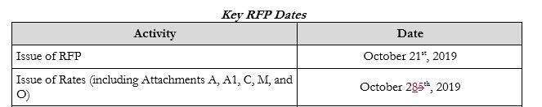

- In Section 2.2.7 Acceptance of Capitation Rates:
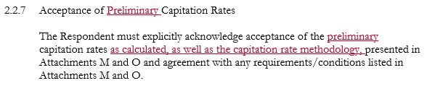
- In Section 2.5 PRICING:

